**BUILD AN EVENT**

**MANAGEMENT SYSTEM**

**USING SALESFORCE**

PROJECT REPORT TEMPLATE

1. INTRODUCTION
   1. OVERVIEW

Event create opportunities for people to connect with an area, spend time together, celebrate and experience the diversity of cultures and foster creativity and innovation. They allow a community to come alive and provide an opportunity for a destination to showcase its tourism experience and increase economic activity. Events contribute significantly to community building, lifestyle and leisure enhancement cultural development, tourism promotion and increased visitation, volunteer participation ,fundraising and economic development. Most importantly events create a sense of sun and vibrancy, resulting in a strong sense of community Connectivity, pride and a sense of place.

* 1. **PURPOSE**

Create and maintaining an event. This process spans from the very beginning of planning all the way to post-event manager makes planning decisions, such as the time, location, and theme of their event.

1. PROBLEM DEFINITION & DESIGN THINKING
   1. **EMAPATHYMAP**

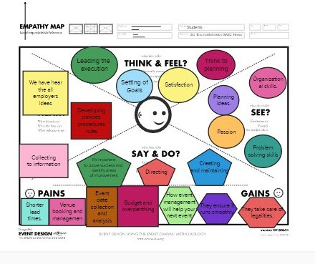

* 1. IDEATION &BRAINSTORMING THINKING

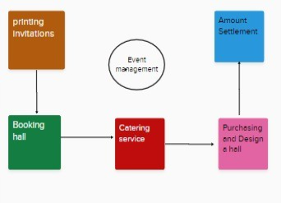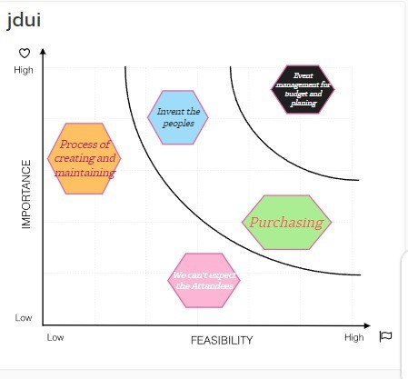

1. **RESULT**
   1. DATE MODEL:

|  |  |  |
| --- | --- | --- |
| Object name | Fi ed in the object | |
|  | Data type | Text |
| Fi ed label | Enter city |
| Data type | Master- detail  relationship |
| Fi ed type | Event |

|  |  |  |
| --- | --- | --- |
| 2. Attendees | Data type | Auto number |
| Filed label | ID |
| Data type | Phone |
| Filed label | Phone |
| Data type | Email |
| Filed label | Email |
| Data type | Pick list |
| Filed label | Tickets |
| 3. speaker | Data type | Text area |
| Filed label | Bio |
| Data type | Email |
| Filed label | Email |
| Data type | Look- up  relationship |
| Filed label | Event |
| 4.Vendors | Data type | Email |
| Filed label | Email |
| Data type | Phone |
| Filed label | Phone |
| Data type | Text |
| Filed label | Service provider |
| Data type | Look-up relationship |
| Filed label | Event |

* 1. **ACTIVITY & SCREENSHOTS**

Create objects:

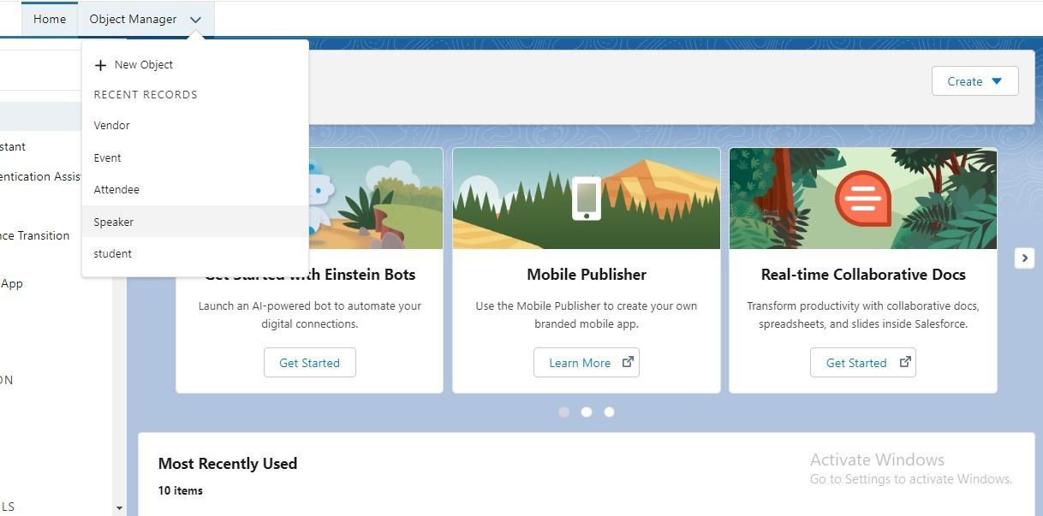

**Tab**s:

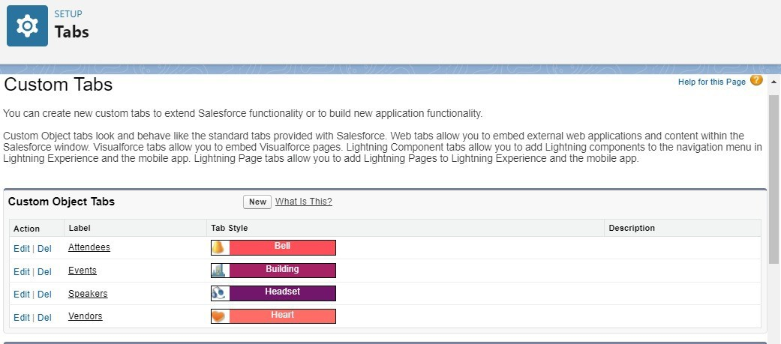

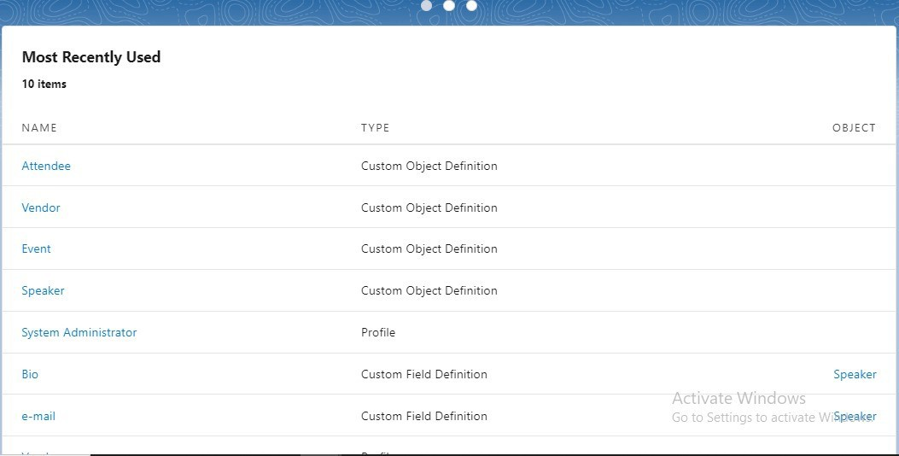

**Field s:**

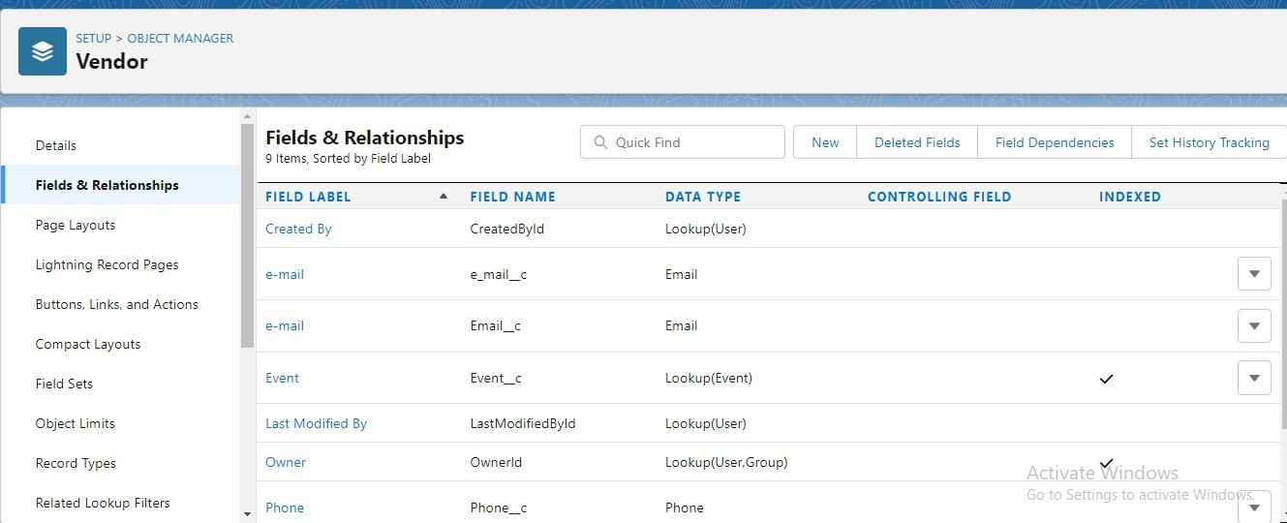

**Profiles:**

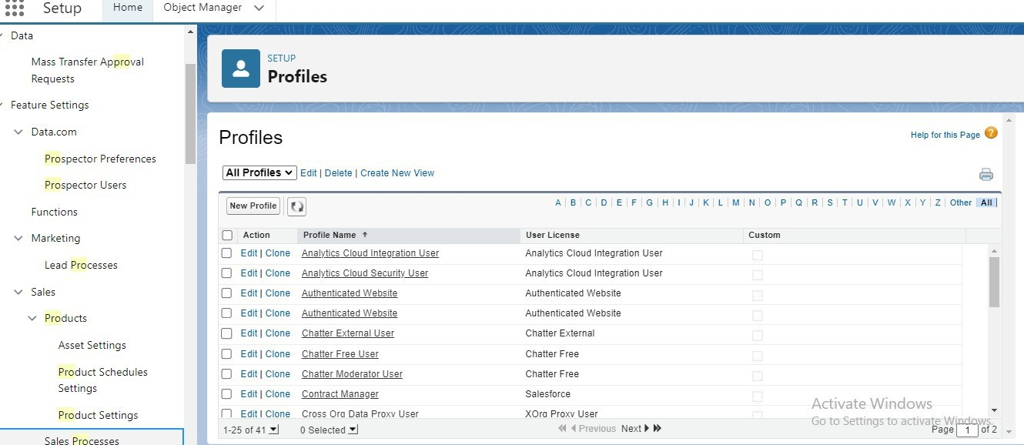

Users:

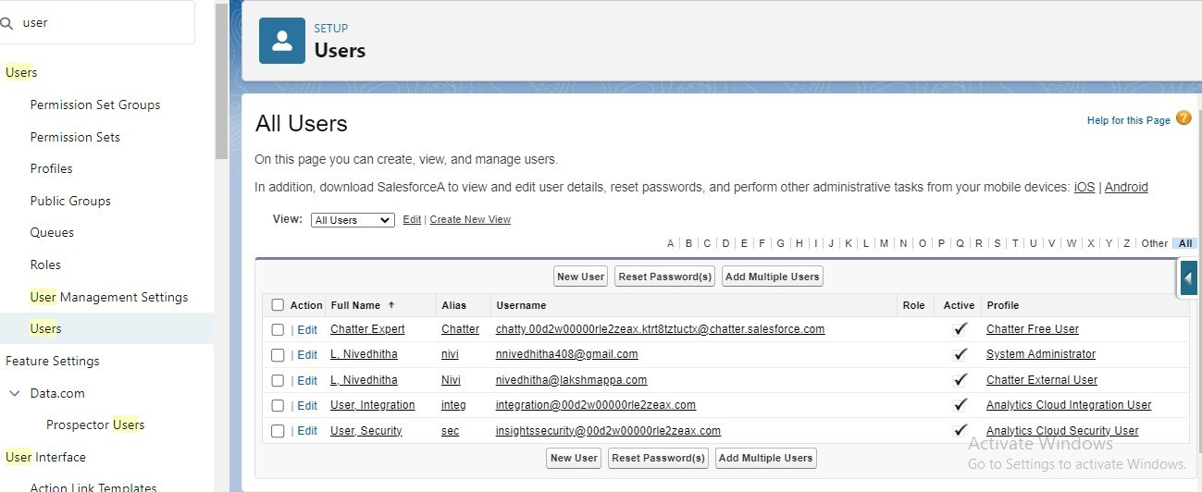

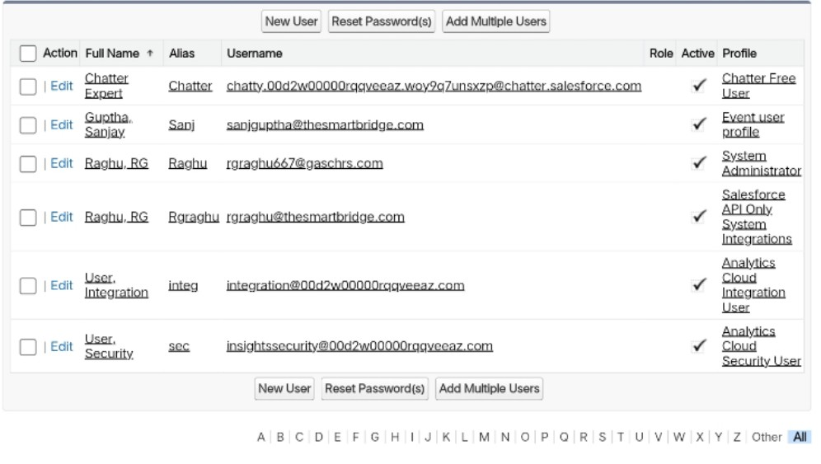

Permission sets:

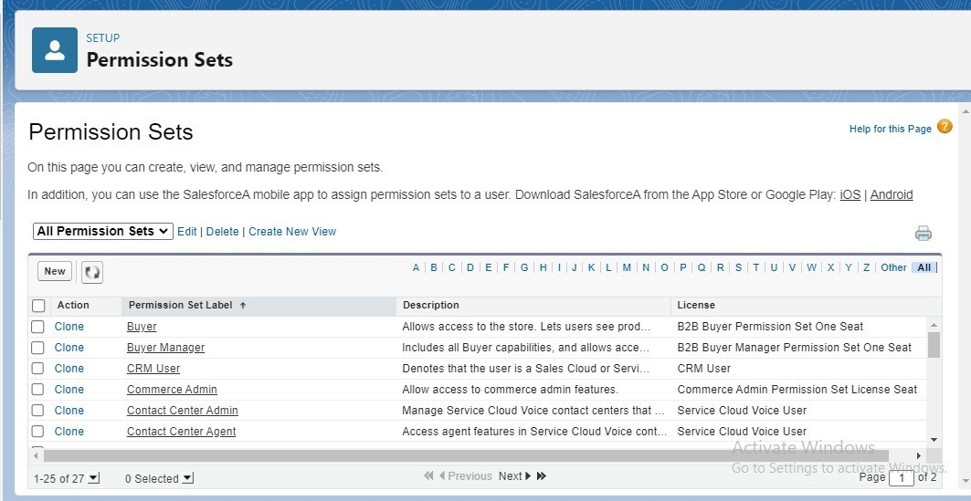

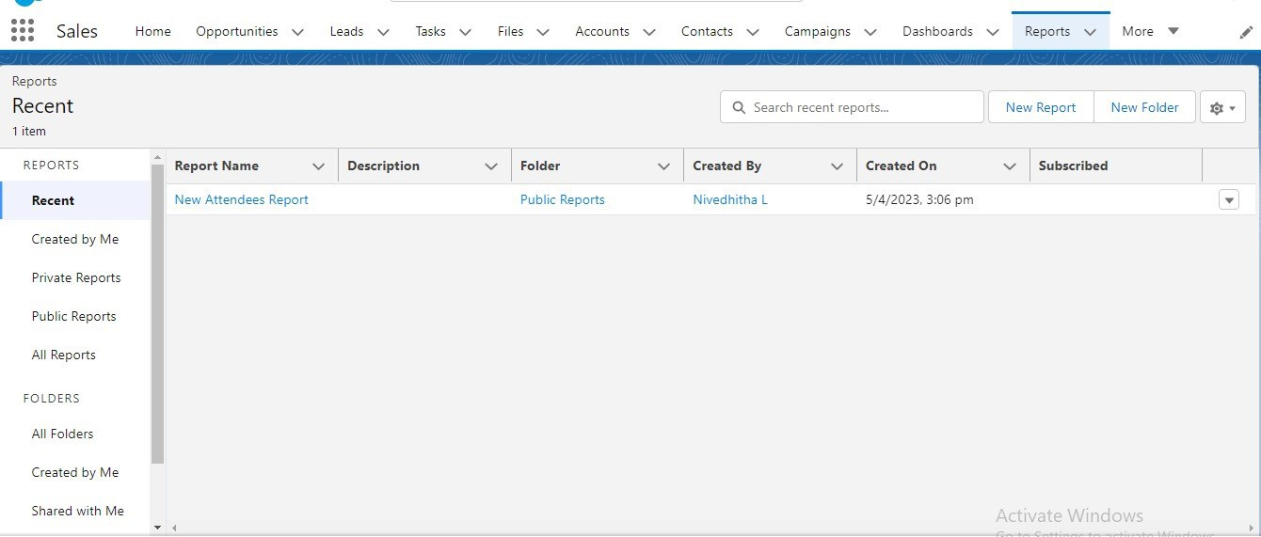Reports:

1. **TRAILHEAD PROFILE PUBLIC URL**

Team lead - https://trailblazer.me/id/raghu1245

Team member1- https://trailblazer.me/id/mmoorthy13 Team member2- https://trailblazer.me/id/nbabu127 Team member – https://trailblazer.me/id/lyadav103

1. ADVANTAGES & DISADVATAGES

**Advantages**:

* Opportunities for creativity.
* Ability to work on different events.
* Chance to work with diverse clients.
* Collaborative work environment.
* High projections for job growth.
* Few educational requirement.
* Unconventional work hours.

**Disadvantages:**

* One of the most common challenges that event planners face is budgeting.
* Understaffing problems.
* Picking the right venue.
* Technological challenges.
* Keeping track of event plan for bad weather.
* Lack of event planning experience.
* Time management.

1. **APPLICATION**

Studying event management enhances the management techniques inorganizing success events like brand launch promotional events, music concerts, fashion shows, personal events, press conference, exhibitions, etc. These require approach ana skill that is leant in the media college.

1. **CONCLUSION**

A successful event holds the execution of a lot of little processes. All the takes are aligned and executed by a plan. An expert event planner defines the plan According to the requirement of the host. The main reasons for organizing events are to create awareness, build reputation, and effectively convey your message. It provides great exposure to your ceremony or product launch, which can be beneficial for your business in more than one way.

1. **FUTURE SCOPE**

Event management is the process of planning various types of events. These events can be from small networking meetings to a social event. Event management as a career is a multifaceted activity. It involves management, creation and development of events such as corporate conferences, wedding, festivities, formal parties etc. It involves a lot of Research about the brand, target audience and the concept of the event before planning the actual event.